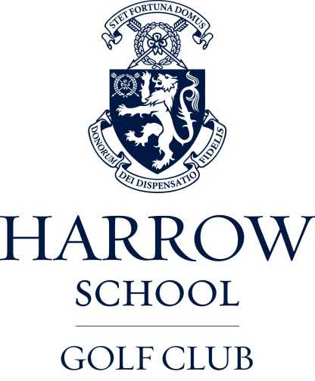

MODUS OPERANDI

- The name of the Club shall be Harrow School Golf Club, Ladies’ Section

- The Activities of the Section shall be managed by a Committee of six members of the Club.

- The committee shall consist of:
  - The Captain
  - Vice-Captain
  - The Secretary
  - Handicap Secretary
  - Treasurer
  - Competition and Tournament Secretary

In addition the committee may co-opt one or two other members (to work as one), who are non-voting.

- Four of the voting members of the Committee attending a previously agreed committee meeting shall constituent a quorum.

- Committee meetings shall be held at least termly at such times and places as the Committee shall decide.

- The Annual General meeting of the Ladies Section shall be held in the autumn of each year.

- Members of the Committee shall be elected for three years with two members retiring every year. They may stand for re-election. Casual vacancies arising out of premature retirement shall be filled by co-opting a new member to serve the remainder of that golfing year.

October 2015

